UBF KENYA EASTER BIBLE CONFERENCE REPORT BY PASTOR JUMA FUCHINGO

YOUNG MAN, GET UP!
“Then he went up and touched the coffin, and those carrying it stood still. He said, ‘Young man, I say to you, get up!’” (Luke 7:14)
With the declining COVID-19 threat in Kenya, we held our Easter Bible conference physically for the first time since the first COVID-19 case was declared in Kenya in March 2020. We had a two day conference between 16th and 17th April 2022. This year our conference theme was, “Young man, Get up!” from Luke 7:11-14. The key verse was 14 “Then he went up and touched the coffin, and those carrying it stood still. He said, "Young man, I say to you, get up!" We prayed and purposed this conference mainly to revive our leadership rather than inviting new members. Thus, it was more of leaders’ conference. This time we targeted our almost 20 graduate members in order to strengthen them so that they may grow as good coworkers especially raising young student members. A total of 50 members attended our conference this year. At the same time we had a separate CBF program with 30 attendants.

Through this conference, we prayed that we may hear Jesus word and get up from our spiritual coffins and come back to life again. This way, we can overcome our spiritual laxity and laziness and spring up again into spiritual life and renew our calling to once again go back to the mission field to fish and take care of lost campus students.

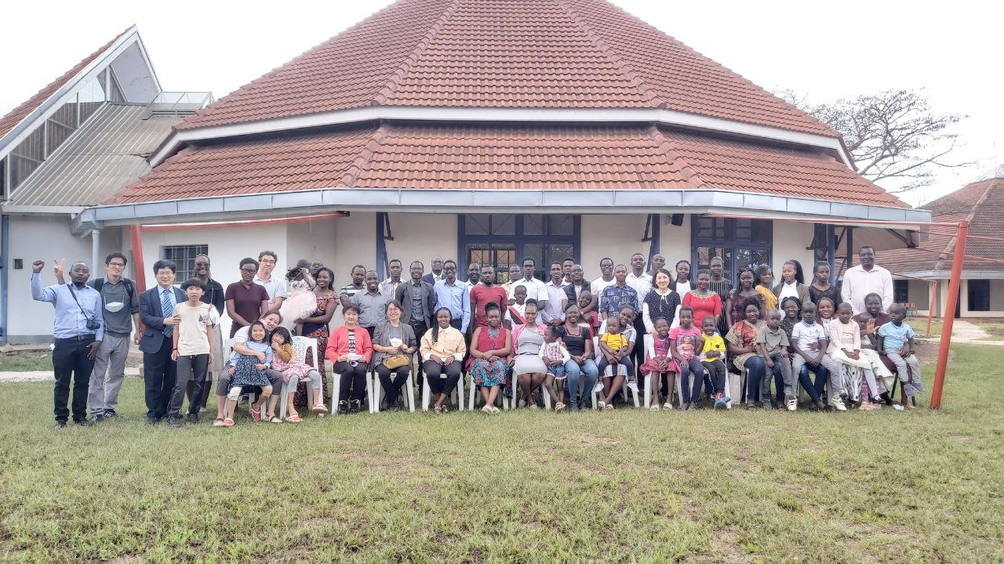

Our program was packed and we focused on listening to God’s word with one opening message and three main messages. There were also two representative testimonies at the end of each message which were served by graduate members. P. Juma Fuchingo served the opening message from Isaiah 43:14-28 with the title “see I am doing a new thing” The key verse was 14 “See, I am doing a new thing! Now it springs up; do you not perceive it? I am making a way in the desert and streams in the wasteland." Through this message, he gave us direction of the conference by calling us to forget the former things, look ahead and see the new thing God was doing in our lives. S. Cosmas Karisa served main 1 based on Luke 7:11-17 “Young man get up!” He shared his heart moving testimony and prays to wake up spiritually and feed sheep. He also wants to overcome judgmental spirit and prepare his heart to obey God through marriage by faith. Main Message two was served by S. Fredrick Odhiambo based on Isaiah 53:1-12, “By his wounds, we are healed.” This was our Easter celebration message to remember Jesus’ salvation work on the cross. He shared his past struggled with unfaithful behavior at his work and prayed for forgiveness through Jesus by his salvation grace.

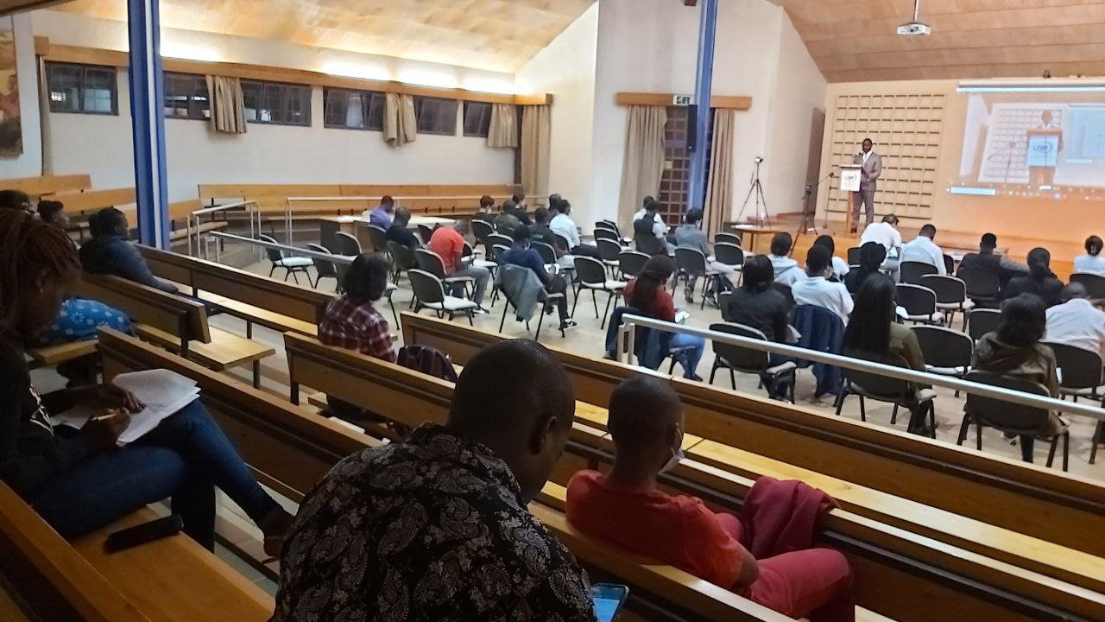

Finally, main 3 was based on John 21:1-17 “Feed my sheep” It was our commissioning message to send us back to God’s harvesting field by re-committing ourselves to feed sheep. This message was served by S. Kennedy Onyango. He engaged in 2019 during our 30th anniversary but due to COVID-19 and human struggle, they could not establish their house church. He could confess his wrong attitude and character for marriage and acknowledged Jesus command to him to show his love first to Jesus by feeding sheep. Then he can show true Jesus love to his coworker. He prayed that God may open the way for their marriage to be established this year.

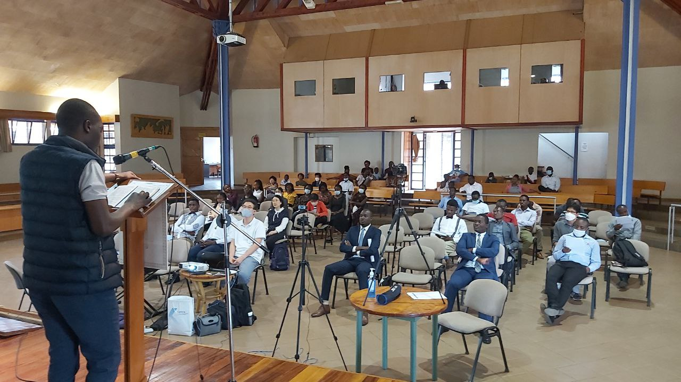

During this conference, our missionaries and senior shepherds devoted themselves to fully support by preparing the testimony speakers and messengers. All the servants showed a great spirit of willingness and devotion to serve this conference. We witnessed powerful testimonies from among our members who were deeply touched by the messages. Especially two of our graduate sisters felt revived by this conference and shared powerful testimonies with a clear spiritual decision making to feed sheep.
Our prayer topics are:
1. To restore full off-line Sunday worship service
2. To reach out campus to feed at least one sheep by each leader
3. For the ministry succession by the end of the year

One word: Young man, get up!

